// Johan Jomy Kuruvilla 10 - CSB
// Disk Scheduling - FCFS

#include <stdio.h>
#include <stdlib.h>

void main() {
int n;
int queue[100];

printf("Enter the number of disk requests: ");
scanf("%d", &n);

printf("Enter the disk queue sequence: ");
for (int i = 0; i < n; i++) {
scanf("%d", &queue[i]);
}

int head;
printf("Enter the initial head position: ");
scanf("%d", &head);

int total_seek_time = 0;
printf("\nOrder of disk access:\n");
printf("%d", head);

for (int i = 0; i < n; i++) {
printf(" -> %d", queue[i]);
total_seek_time += abs(queue[i] - head);
head = queue[i];
}

printf("\nTotal seek time = %d\n", total_seek_time);
printf("Average seek time = %.2f\n",(float)total_seek_time / n);

}

// Johan Jomy Kuruvilla 10 - CSB
// Disk Scheduling - Scan

#include <stdio.h>
#include <stdlib.h>

void main() {
int n, head, direction, disk_size;
int queue[100], seek_sequence[200];
int total_seek_time = 0, index = 0;

printf("Enter the number of disk requests: ");
scanf("%d", &n);

printf("Enter the disk requests: ");
for (int i = 0; i < n; i++) {
scanf("%d", &queue[i]);
}

printf("Enter the initial head position: ");
scanf("%d", &head);

printf("Enter the disk size: ");
scanf("%d", &disk_size);

printf("Enter direction (0 for left, 1 for right): ");
scanf("%d", &direction);

queue[n] = head;
n++;

for (int i = 0; i < n - 1; i++) {
for (int j = 0; j < n - i - 1; j++) {
if (queue[j] > queue[j + 1]) {
int temp = queue[j];
queue[j] = queue[j + 1];
queue[j + 1] = temp;
}
}
}

int head_index = 0;
for (int i = 0; i < n; i++) {
if (queue[i] == head) {
head_index = i;
break;
}
}

if (direction == 1) {
for (int i = head_index + 1; i < n; i++) {
seek_sequence[index++] = queue[i];
}
if (queue[n - 1] != disk_size - 1) {
seek_sequence[index++] = disk_size - 1;
}
for (int i = head_index - 1; i >= 0; i--) {
seek_sequence[index++] = queue[i];
}
}

else {
for (int i = head_index - 1; i >= 0; i--) {
seek_sequence[index++] = queue[i];
}
if (queue[0] != 0) {
seek_sequence[index++] = 0;
}
for (int i = head_index + 1; i < n; i++) {
seek_sequence[index++] = queue[i];
}
}

printf("\nOrder of disk access:\n%d", head);
for (int i = 0; i < index; i++) {
printf(" -> %d", seek_sequence[i]);
total_seek_time += abs(head - seek_sequence[i]);
head = seek_sequence[i];
}

printf("\nTotal seek time = %d\n", total_seek_time);
printf("Average seek time = %.2f\n", (float)total_seek_time / n);
}

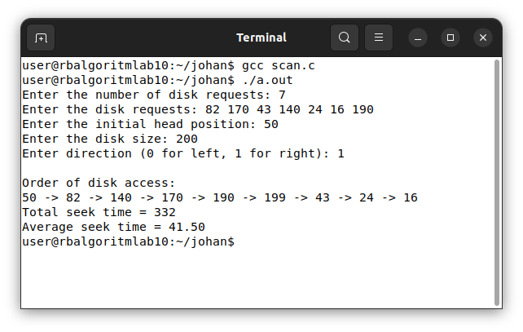

// Johan Jomy Kuruvilla 10 - CSB
// Disk Scheduling - C-Scan

#include <stdio.h>
#include <stdlib.h>

void main() {
int n, head, direction, disk_size;
int queue[100], seek_sequence[200];
int total_seek_time = 0, index = 0;

printf("Enter the number of disk requests: ");
scanf("%d", &n);

printf("Enter the disk requests: ");
for (int i = 0; i < n; i++) {
scanf("%d", &queue[i]);
}

printf("Enter the initial head position: ");
scanf("%d", &head);

printf("Enter the disk size: ");
scanf("%d", &disk_size);

printf("Enter direction (0 for left, 1 for right): ");
scanf("%d", &direction);

queue[n] = head;
n++;

for (int i = 0; i < n - 1; i++) {
for (int j = 0; j < n - i - 1; j++) {
if (queue[j] > queue[j + 1]) {
int temp = queue[j];
queue[j] = queue[j + 1];
queue[j + 1] = temp;
}
}
}

int head_index = 0;
for (int i = 0; i < n; i++) {
if (queue[i] == head) {
head_index = i;
break;
}
}

if (direction == 1) {
for (int i = head_index + 1; i < n; i++) {
seek_sequence[index++] = queue[i];
}
if (queue[n - 1] != disk_size - 1) {
seek_sequence[index++] = disk_size - 1;
}
seek_sequence[index++] = 0;
for (int i = 0; i < head_index; i++) {
seek_sequence[index++] = queue[i];
}
}
else {
for (int i = head_index - 1; i >= 0; i--) {
seek_sequence[index++] = queue[i];
}

if (queue[0] != 0) {
seek_sequence[index++] = 0;
}
seek_sequence[index++] = disk_size - 1;
for (int i = n - 1; i > head_index; i--) {
seek_sequence[index++] = queue[i];
}
}

printf("\nOrder of disk access:\n%d", head);
for (int i = 0; i < index; i++) {
printf(" -> %d", seek_sequence[i]);
total_seek_time += abs(head - seek_sequence[i]);
head = seek_sequence[i];
}

printf("\nTotal seek time = %d\n", total_seek_time);
printf("Average seek time = %.2f\n", (float)total_seek_time / n);
}

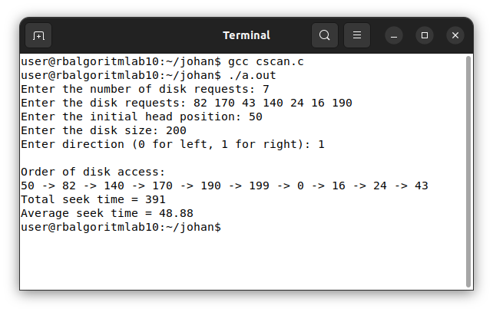

// Johan Jomy Kuruvilla 10 - CSB
// Memory Allocation - First Fit

#include <stdio.h>

void main() {
int n, m;

printf("Enter number of memory blocks: ");
scanf("%d", &n);

int blocks[n], flag[n];

printf("Enter sizes of %d memory blocks: ", n);
for (int i = 0; i < n; i++) {
scanf("%d", &blocks[i]);
flag[i] = 0;
}

printf("Enter number of processes: ");
scanf("%d", &m);
int processes[m], allocation[m];

printf("Enter sizes of %d processes: ", m);
for (int i = 0; i < m; i++) {
scanf("%d", &processes[i]);
allocation[i] = -1;
}

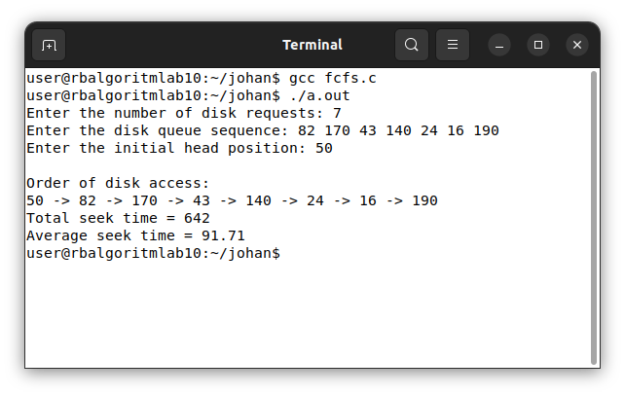

for (int i = 0; i < m; i++) {
for (int j = 0; j < n; j++) {
if (flag[j] == 0 && blocks[j] >= processes[i]) {
allocation[i] = j;
flag[j] = 1; // block occupied
break;
}
}
}

printf("\nProcess No.\tProcess Size\tBlock No.\n");
for (int i = 0; i < m; i++) {
printf("%d\t\t%d\t\t", i + 1, processes[i]);
if (allocation[i] != -1)
printf("%d", allocation[i] + 1);
else
printf("Not Allocated");
printf("\n");
}
}

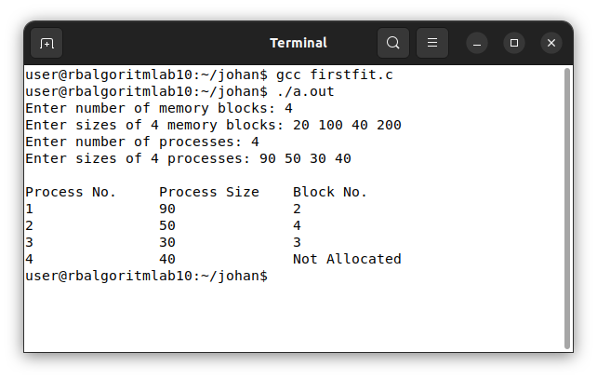

// Johan Jomy Kuruvilla 10 - CSB
// Memory Allocation - Best Fit

#include <stdio.h>

void main() {
int n, m;

printf("Enter number of memory blocks: ");
scanf("%d", &n);
int blocks[n], flag[n];

printf("Enter sizes of %d memory blocks: ", n);
for (int i = 0; i < n; i++) {
scanf("%d", &blocks[i]);
flag[i] = 0;
}

printf("Enter number of processes: ");
scanf("%d", &m);
int processes[m], allocation[m];

printf("Enter sizes of %d processes: ", m);
for (int i = 0; i < m; i++) {
scanf("%d", &processes[i]);
allocation[i] = -1;
}

for (int i = 0; i < m; i++) {
int bestIdx = -1;
for (int j = 0; j < n; j++) {
if (flag[j] == 0 && blocks[j] >= processes[i]) {
if (bestIdx == -1 || blocks[j] < blocks[bestIdx])
bestIdx = j;
}
}

if (bestIdx != -1) {
allocation[i] = bestIdx;
flag[bestIdx] = 1;
}
}

printf("\nProcess No.\tProcess Size\tBlock No.\n");
for (int i = 0; i < m; i++) {
printf("%d\t\t%d\t\t", i + 1, processes[i]);
if (allocation[i] != -1)
printf("%d", allocation[i] + 1);
else
printf("Not Allocated");
printf("\n");
}
}

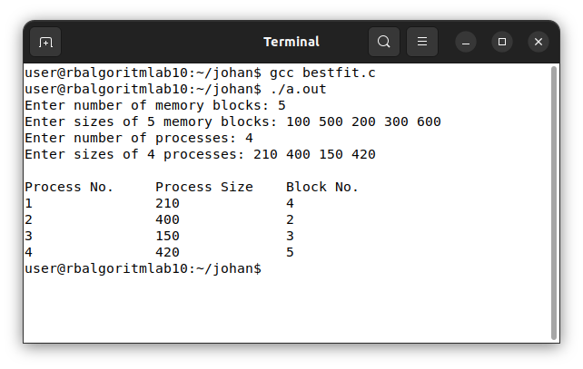

// Johan Jomy Kuruvilla 10 - CSB
// Memory Allocation - Worst Fit

#include <stdio.h>

void main() {
int n, m;

printf("Enter number of memory blocks: ");
scanf("%d", &n);
int blocks[n], flag[n];

printf("Enter sizes of %d memory blocks: ", n);
for (int i = 0; i < n; i++) {
scanf("%d", &blocks[i]);
flag[i] = 0;
}

printf("Enter number of processes: ");
scanf("%d", &m);
int processes[m], allocation[m];

printf("Enter sizes of %d processes: ", m);
for (int i = 0; i < m; i++) {
scanf("%d", &processes[i]);
allocation[i] = -1;
}

for (int i = 0; i < m; i++) {
int worstIdx = -1;
for (int j = 0; j < n; j++) {
if (flag[j] == 0 && blocks[j] >= processes[i]) {
if (worstIdx == -1 || blocks[j] > blocks[worstIdx])
worstIdx = j;
}
}

if (worstIdx != -1) {
allocation[i] = worstIdx;
flag[worstIdx] = 1;
}
}

printf("\nProcess No.\tProcess Size\tBlock No.\n");
for (int i = 0; i < m; i++) {
printf("%d\t\t%d\t\t", i + 1, processes[i]);
if (allocation[i] != -1)
printf("%d", allocation[i] + 1);
else
printf("Not Allocated");
printf("\n");
}
}

